TFS #92360

CW 29: Make Lien Positioning Configurable by ACA

Overview

Fix so Lien Position is not defaulted and also display loan position in the Collateral Analysis grid since it is an attribute of the Loan to Collateral so can be edited on that grid

April Beston

09/07/2016

Table of Contents

TFS # 1

Description 2

Testing Notes 2

Screen Shots and Steps Taken 2

# Description

Original Title: CW 29: Make Lien Positioning Configurable by ACA

BCM 8/5/16 - Original Request: "Would like lien position to be shut off for FCE. If can't be shut off, shouldn't default to 2 when there are multiple security documents."

FPI Notes/Examples: Make lien positioning configurable by ACA, then configure off for FCE and Yankee (BCM p/c with Kyle Lussier on 8/8/16).

 RJM 8/8/16 -

This was item #29 from the Collateral Web Enhancements list.

Linked to item #39 & #43.

From Bob's comments to EPC:

Rationalization: Productivity concerns, lots of rekeying, causes some service now cases to be created impacting FPI staff as well

Designed Solution: Fix so Lien Position is not defaulted and also display loan position in the Collateral Analysis grid since it is an attribute of the Loan to Collateral so can be edited on that grid

RMW 8/17/16 - The "display loan position in the Collateral Analysis grid since it is an attribute of the Loan to Collateral so can be edited on that grid" part of this will be done under TFS 92363.

# Testing Notes

Test to ensure that “Lien Position” is not displayed on the “Update Relationship” screen for FCE and Yankee, but still displays for all other associations.

Test passed:

FCE – Customer: Johnson Cranberries Limited

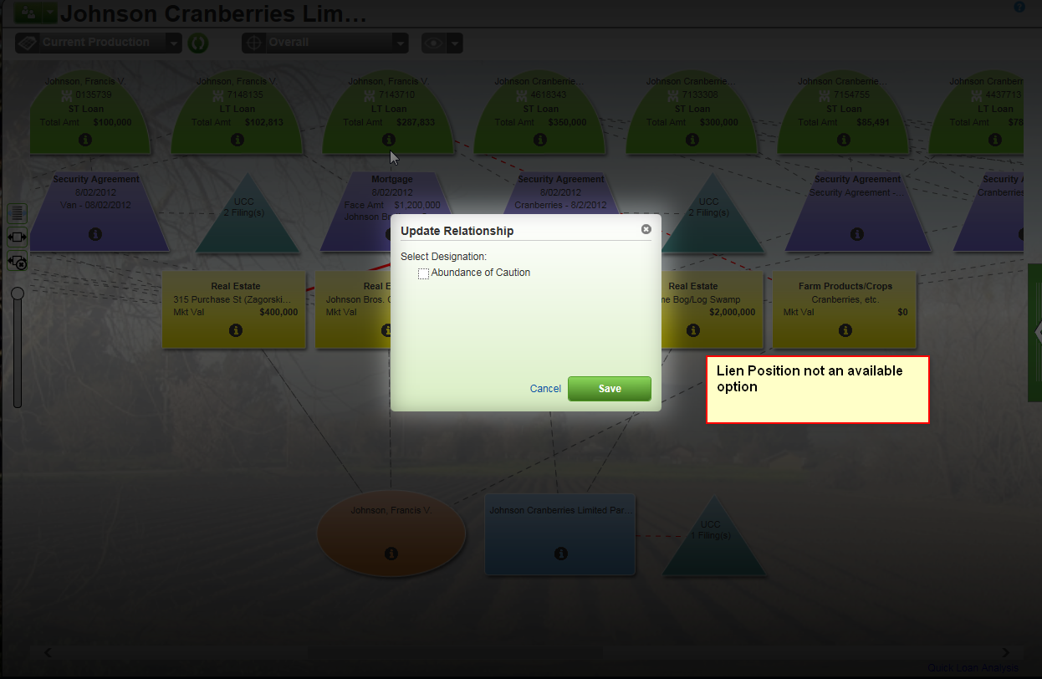

Yankee – Customer: Adams Apple Orchard

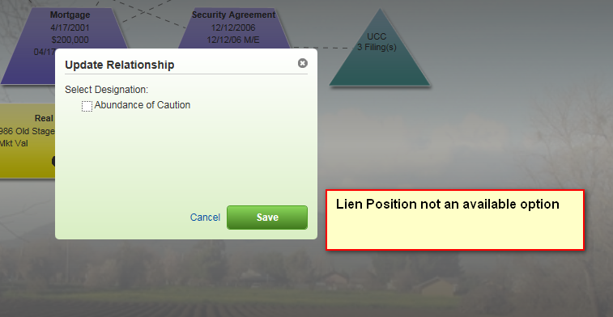

FCW – Customer: Baschma, Jahna

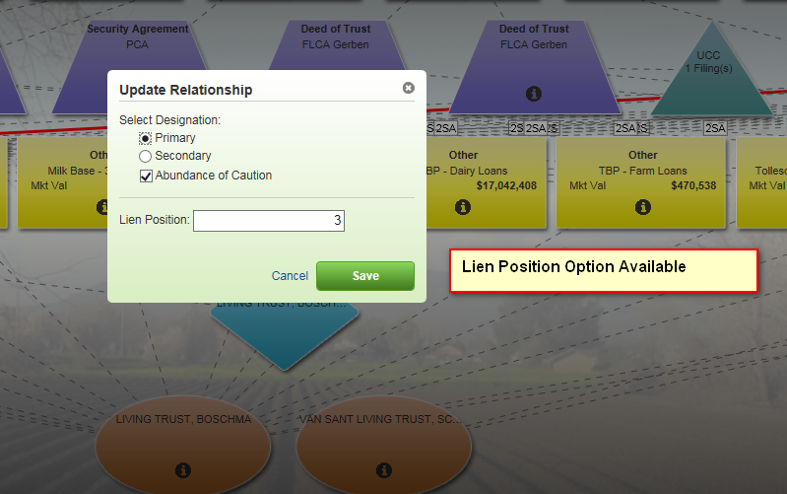

NWFCS – Customer: Tombre, Tyler M

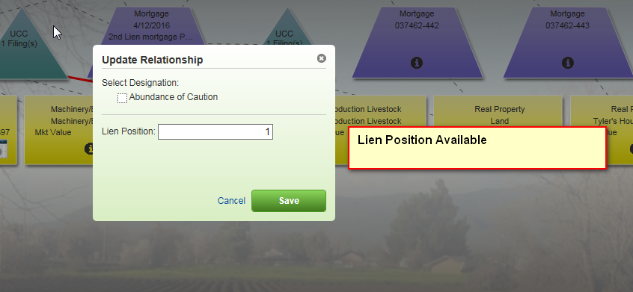

AgCountry – Customer: J & J Bachand Farms Inc

